Task - Week 16:

1. ***On the basis of chapter 3 in ‘Veje til et nyt sprog – teorier om sprogtilegnelse’ write about, describe and discuss the three presented hypotheses on language acquisition on pp. 48-55 Input, output og interaction: Tre hypoteser om sprogtilegnelse.***

* **Stephen Krashen, Input hypothesis:** He believes that language acquisition is achieved in a specific order. Input has to be adjusted in a way that is understandable. The difficulty is shown through Krashen´s i+1. i stands for the level of interlanguage knowledge a learner has and 1 is the next step in learning process. The teacher´s task is to simplify tasks and make it adjustable.
* **Michael Long, Interaction hypothesis:** A simplified input is necessary for a learner to obtain a language. He uses a term called “negotiation of meaning” to be able to find this simplified input. “Negotiation of meaning” is a negotiation between to partners; a language user shows his partner that he does not know how to say something in the target language and then the partner finds a way to adjust his language. This way of learning requires a communicative approach.
* **Merrill Swain, Output hypothesis:** Output is important. She believes that when at student is forced to speak and find a way of expressing oneself, it will create a more fluent language and an awareness on language acquisition. She mentions different functions in which leads to language acquisition; *awareness, to test a hypothesis and metalanguage reflection*.

1. **On the basis of chapter 4 in ‘Veje til et nyt sprog – teorier om sprogtilegnelse’ write about, describe and discuss the depicted learning view on pp. 56-65 Den lingvistiske tilgang: Det ligger i sproget pp.66-83.**

Contrastive analysis-hypothesis states that the linguistic difference between the target language and the native language decides whether a language is difficult or easy to obtain an learn.

Jakob Steensig says that *“the learner uses his native language when making hypotheses and therefore it is important that the teacher knows the fundamental ways of working with this and know how to give feedback and work with these hypotheses in an improving way”*

An important thing when learning a target language and some difficulties involving this is pronunciation The pronunciation is achieved and implied when using the tongue, throat and mouth etc. Some learners who wants to learn a target language sometimes intend to use a sound or a letter used in a word and then directly translate it from their native language to their target language, even though it is incorrect.

Some researches point out some connections in linguistic awareness and learning when looking at it in a wide perspective called typology. Language is compared to a biological phenomenon and is something in which is formed by the environment.

Joseph Greenberg is interested in the difference in sentence construction and how to use sentence members. In Danish we use SOV-construction. It means a sentence is constructed with a subject, verb and at last an object. When looking at this construction in Turkish language the sentence is constructed in a SVO-way. This also leads to at different look at prepositions. Relating to this it is also mentioned that relative clauses also is looked at differently when learning a new language. In Danish we have several options when using a relative clause in contrast to some other languages.

1. **On the basis of chapter 5 in ‘Veje til et nyt sprog – teorier om sprogtilegnelse’ write about, describe and discuss the defined learning view on pp. 66-83 Den kognitive tilgang: Det foregår i hovedet**

A learner is an active part of the grammatical view. These cognitive theories weigh input, output and interaction equally high when developing your language.

This is also shown through this model:

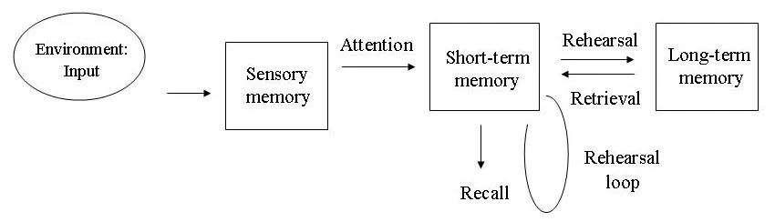

We will get some input ins which we register and find out if we want to work with and use. Some of this will get lost and the learner uses his attention and awareness to store it in his short term language. Here some input will disappear and the learner will forget it, but some of the knowledge will stay in the brain and create a reflection process and then be stored in our long term memory. Maybe after using some different memorization strategies etc.

Krashen talks about two different ways of obtaining a language*; through acquisition and learning*. Acquisition is what happens when being with other people and the focus is on the content. Learning happens in a school environment where students are placed in a more staged environment. According to Krashen you can´t use anything learned in school in an every-day life situation and vice versa. Krashen then says that for a learner to be able to use something learned in school in another situation the learner then uses his monitor; his own awareness of what he is about to say. This requires a focus on form and that the learner is given a reasonable amount of time.

Richard Schmidt does not agree with Krashen. He believes that the form in language is a higher priority before a learner is going to acquire a language. The goal with his theory is to state the importance of awareness. When using this term it is important to mention three factors influencing on the language acquisition; *intention, knowledge and* *attention.* Attention can be divides into several grades; *sense perception, noticing and understanding*.

Schmidt believes that the input is central when acquire a language and that an attention on specific elements in a language concludes what kind of input that stays in the long term memory.

1. **On the basis of chapter 6 in ‘Veje til et nyt sprog – teorier om sprogtilegnelse’ write about, describe and discuss the described learning view on pp. 84-95 kap. 6 Den sociale tilgang: Det sker mellem os.**

Communication happens among people and we need to look at it from a social point of view. The Russian phycologist Lev Vygotsky. He uses the term *“the zone of proximal development”* when referring to how learners acquire a language. The zone is defined as a place in between tasks solved with help from a teacher and then tasks solved without any help. Jerome Bruner uses the term scaffolding teaching – this teaching is based on teacher oriented support and help in which later results in students being more independent and able to solve tasks alone or in groups.

This is also something in which this chapter concludes: *“konklusionen er derfor at kollektiv stilladsering kan føre til indviduel sprogtilegnelse”.*

It is also mentioned that cultural differences are important when learning a language. If you have an insight in a given culture, you have a better chance to learn a language from this culture. This is something that John Schumann claims in his theory. Bonny Pierce talks about the fact that a person has many identities dependent on where the person is. Schumann claims that our social patterns and surroundings influences on the way we acquire a language.